CHAPTER TWO
VOCABULARY BUILDING
Objective: To enable the students expand their vocabulary so as to enhance their proficiency in reading and listening to academic texts, writing and speaking.
2.1. WORD FORMATION PROCESS
COMPOUNDING
Definition: the process of combining two or more words to form a new word
Closed compound words are formed when two unique words are joined together. They don’t have a space between them and they are the type that generally comes to mind when we think of compound words. For example: water+bed= waterbed, door+knob= doorknob, wall+paper= wallpaper, grand+mother= grandmother, up+side= upside, fire+flies= fireflies, play+things= playthings
Open compound words have a space between the words but when they are read together a new meaning is formed: ice cream, attorney general, post office, grand jury, middle class, full moon, real estate
CLIPPING
Definition: Clipped words are words shortened by common use; they are a shortened abbreviation of a word, which makes them easier to spell and write.
Clip  Word | Original  Word | Clip  Word | Original  Word
Ad | Advertisement | margarine | Oleomargarine
alum | Alumni | mart | Market
auto | Automobile | math | Mathematics
bike | Bicycle | memo | Memorandum
Lab | Laboratory | mend | Amend
Bro | Brother | mike | Microphone
burger | Hamburger | miss | Mistress
bus | Omnibus | mod | Modern
bust | Burst | movie | moving pictures

BLENDING
Definition: Blending is the word formation processes in which parts of two or more words combine to create a new word whose meaning is often a combination of the original words.
- advertisement + entertainment → advertainment
- biographical + picture → biopic
- breakfast + lunch → brunch
- chuckle + snort → chortle
- cybernetic + organism → cyborg
- guess + estimate → guesstimate
- hazardous + material → hazmat
- motor + hotel → motel
- simultaneous + broadcast → simulcast
- smoke + fog → smog
- spoon + fork → spork
- telephone + marathon → telethon
- web + seminar → webinar
DERIVATION
Definition: Derivation is the process of forming a new word on the basis of an existing word.
Happiness and unhappy from happy, drinkable from drink, modernise from modern, reddish from red, personally from personal, recreational from recreation, deliverance from deliver, writer from write
CREATIVE RESPELLING
Definition: Sometimes words are formed by simply changing the spelling of a word that the speaker wants to relate to the new word. Product names often involve creative respelling, such as Mr. Kleen.
Enuff Z'Nuff Enuff Z'Nuff (a pronunciation respelling of "enough's enough"), is an American rock band from Blue Island, Illinois.
The now chiefly North American "airplane" is not a respelling but a recoining, modelled after "airship" and "aircraft".
Thompson even respelled Baum's respelling "Nome" as the more traditional "Gnome".
COINING WORDS
Definition: A coined word (or neologism) is a word that has been inspired by a person or event.
Here are a few unique neologisms:
- Metrosexual - a man who dedicates a lot of time and money to his appearance
- Staycation - a vacation at home or near one’s home
- Webinar - online seminar
- Banana Republic - politically unstable country that depends on exports
- Butterfingers - clumsy person
- Chortle - chuckle + snort
- Factoid - doubtful fact that has no back-up proof
- Oxbridge = Oxford + Cambridge
- Workaholic - taken from the suffix “-holic”, which means addiction
- Yahoo - primitive people with materialistic ways of thinking
BORROWING WORDS
Definition: Loanwords are words adopted by the speakers of one language from a different language (the source language).

1. ANONYMOUS (GREEK)
The word ‘anonymous’ comes from the Greek word ‘anōnumos’. Anōnumos is defined as something or someone without a name, similar to the English meaning which defines the word as someone who does not reveal their identity.
2. LOOT (HINDI)
Pronounced and defined in the exact same manner in English as it is in the origin language Hindi, the word ‘loot’ refers to stolen goods/property.
For example, a dacoit or robber would keep the ‘loot’ hidden from the eyes of the police.
The word can also be used as a verb, for example, “they looted all the banks in the town post the civil war.’
3. GURU (SANSKRIT)
The word ‘guru’ is derived from the Sanskrit language, in which the definition goes beyond that of a teacher or an expert of subject. Rather, it describes an individual with influential leadership, exceptional knowledge and deep, thought provoking intelligence.
However, post the change in time and evolution, the term is commonly used to describe a teacher or a learned individual in the English language (as well as in many regional Indian languages).
4. SAFARI (ARABIC)
An expedition or observing animals in their natural atmosphere is called a ‘safari’. The word originates from the Arabic language and, since having been borrowed by the English language, is used widely across the globe right from jungle safaris to the famous desert safari in the Middle East.
5. CIGAR (SPANISH)
While many of you may know what a cigar is, the technical definition is ‘a cylinder of dried and fermented tobacco rolled in tobacco leaves for the purpose of smoking’. Quite a hefty definition for something so small, isn’t it?
The English terms originate from its Spanish equivalent ‘Cigarro’, which too was derived from another foreign language known as Mayan and was called ‘Sicar’.
6. CARTOON (ITALIAN)
Be it the old classics by Walt Disney on screen or the daily strips in the newspaper, everybody loves cartoons!
Described as a sketch or drawing showing the subjects in a humorous manner, the word ‘cartoon’ originates from the Italian term ‘carton’ which initially referred to as a drawing on hard paper and was transformed into comical representation in 1843.
7. WANDERLUST (GERMAN)
Defined as a passionate desire to travel or, quite literally, wander away, the term ‘wanderlust’ derives from German and was borrowed by the English language in 1902.
8. COOKIE (DUTCH)
Did you know this rolled, sliced and baked sweet dough is originated from the Dutch language? It’s true though, it really does.
The English language derived the word ‘cookie’ from the Dutch term ‘Koekie’, defined as akin to cake, to describe this loved sweet snack.
9. KARAOKE (JAPANESE)
A Japanese form of entertainment that took over the Western world 20-30 years ago, Karaoke was borrowed by the English language and has continued to become an international phenomenon for entertainment.
10. METROPOLIS (GREEK)
Derived from Late Latin to Greek initially, the word ‘metropolis’ refers to the mother city of a colony.
The English derivation of the word describes the term as a big city of high importance.
11. LEMON (ARABIC)
The Arabic word from which ‘lemon’ originates is called ‘Laimun’, defined simply as a yellow citrus fruit. The term became a part of the English language family post 1400 and was also influenced by another Middle Eastern language, Persian.
12. AVATAR (SANSKRIT)
Known as a representation of oneself in the virtual world, the word gained a whole new level of popularity after James’ Cameron’s 2009 science fiction film called Avatar.
13. KETCHUP (CHINESE)
Honestly, who would’ve guessed this!
Originating from its Chinese equal ‘Ke-stiap’, the word referred to as a concoction of pickled fish and spices in 1692.
Fast forward 100 years in the Western world, tomatoes were added to the sauce to create the very famous condiment called ‘ketchup’.
14. ENTREPRENEUR (FRENCH)
In the 13th century, the term ‘entrepreneur’ is derived from the French verb ‘entreprendre’ which meant to undertake or do something. History suggests that by the 16th century, the verb had transformed to form the noun ‘entrepreneur’ which referred to someone who undertook a business venture.
15. UTENSIL (FRENCH) (LATIN)
The Latin word ‘utensilia’ refers to things or resources for use and was adapted by the French to form the word ‘ustensile’ which describes cooking tools. By combining the Latin and French versions, the English term ‘utensil’ was then created, and has been commonly used in kitchens across the English-speaking world.

2.2.Prefixes and Suffixes
It is also useful for learners to be aware of the most common prefixes and suffixes and their meanings, since this can help them to understand unfamiliar words. Knowing that hydro- means ‘related to water’, for instance, makes hydroelectric transparent. Many such prefixes and suffixes are derived from classical Greek or Latin, and a number of these are commonly used to form new words (e.g. technophobe, somebody who hates or fears technology, perhaps especially computers).
Prefix | examples | Usual meaning
A | amoral, asexual | not, without
Anglo | Anglo-American | English
Ante | antenatal, antedate | Before
anti- | antisocial, anti-war | Against
cyber- | cybercrime, cyber-culture | computer, internet
de- | defrost, deregulate, deforest | reversing action, take away
dis - | disloyal, disappear, disorder  disconnect, disinfect | not, opposite, reversing action
e- | email, e-commerce ,e-book | electronic, internet
fore- | foretell, foreknowledge | Before
hyper- | extreme(ly) | hypercritical, hypertension
in-  (im - before p)  (il- before I)  (ir- before r) | not, opposite | incomplete,  insensitive  impossible  illegible  irregular

Suffix | Examples | Usual meaning
-age | breakage, shrinkage | instance of
-ation | exploration,  starvation, organization, foundation | process/state of exploration,  starvation  verbs product of
-ее | payee, employee | object of verb
er/or | writer, driver, starter,  editor | person/thing that  does
-ful | spoonful, cupful | amount held in
-hood | brotherhood,  childhood | quality, group,  time of
-ism | communism,  impressionism | belief, practice
-ity | elasticity, falsity | quality of
-ment | government,  arrangement | process/result of
-ness | meanness, happiness | quality of
-ology | Sociology | study of
-phile | Anglophile | lover of
-phobia | Arachnophobia  (fear of spiders) | irrational fear of
-ship | friendship, dictatorship | status, state, quality of
-ese | Chinese, Vietnamese | inhabitant of, language of
-(i)an | Darwinian, republican | supporter of,related to
-ist | Parisian, Moroccan, pianist, racist | citizen of, practitioner of
Combining forms :
Some prefixes and suffixes combine mainly or often with other prefixes and suffixes.
Examples are
phono - ('sound’), -logy ( ‘study of’ ), scope (‘instrument for seeing’),-metry('measurement’).
Phonology telescope micrometry

Negative words with no positive equivalent
Some words with negative prefixes have no positive opposite equivalent. For example somebody can be distressed, but not tressed. Other examples are dishevelled, disappoint, discard, disclose, disconcert, disfigure, dismiss, dispose, incessant, inedible, uncanny, uncouth, ungainly, unkempt, unnerved, unspeakable, unwieldy, unwitting
Productivity
Certain prefixes and suffixes are productive: they are often used to form
new words. And some can be added to almost any word of the right
grammatical kind.
I ’m not anti-tourists; I just don't want them in our town.
The place has got a real 1970s-like atmosphere.
But most are limited to certain words or kinds of word, and cannot be used to
invent new vocabulary items.
(notuncredible, subinteresting, considerageor drinkless)

The Japanese term stands for ‘an empty orchestra’ and is the act of amateur singing with recorded music, commonly performed in clubs or bars.

2.3. Synonyms:
A synonym is a word with the same or a similar meaning as another word. For example, the words big and large are synonyms. Buy and purchase are also synonyms – although we tend to use “buy” in a more informal context, and “purchase” in a more formal context. Some synonyms might not be “perfect” synonyms – there may be slight differences in meaning and connotation.
For example, the words smart and wise. Both of them mean “intelligent,” but the word wise also implies that the person has additional good judgement and deep perception about life. Synonyms are often used in different collocations, too. For example, we can describe either a person or an idea as brilliant, but only a person can be astute.
Antonyms:
Antonyms are words that have contrasting, or opposite, meanings. Like so much of the English language, "antonym" is rooted in the Greek language. The Greek word anti means opposite, while onym means name. Opposite name.There are three different kinds of antonyms.
Complementary: Complementary antonyms have no middle ground. Examples:
- boy - girl, off - on, night - day, entrance - exit, exterior - interior, true - false, dead - alive, push - pull, pass - fail
Relational: These are similar to complementary antonyms, except that both must exist for them to be antonyms of each other. examples:
- above - below, doctor - patient, husband - wife, servant - master, borrow - lend, give - receive, predator - prey, buy - sell, instructor – pupil

Graded: These antonyms deal with levels of comparison and they can be two words on a scale. Many are relative terms, which can be interpreted differently by different people. Examples:
- young - elderly, hard - easy, happy - wistful, wise - foolish, fat - slim, warm - cool, early - late, fast - slow, dark – pale

Here is a list of some common synonyms and Antonyms:
- Abroad – Overseas  - Accord – Agreement  - Admit – Confess  - Agree – Consent  - Alike – Same  - Allow – Permit  - Amount – Quantity  - Angry – Mad  - Answer – Response  - Ask – Inquire | - Exactly – Precisely  - Except – Apart From  - Exit – Leave  - Extra – Additional  - Fair – Unbiased  - False – Untrue  - Famous – Renowned  - Fantastic – Great  - Fast – Quick | - Kind – Benevolent  - Learn – Memorize  - Lethal – Deadly  - Listen – Hear  - Little – Small  - Lots – Many  - Loving – Fond  - Loyal – Faithful  - Lucid – Clear | - See – Look  - Select – Choose  - Significant – Meaningful  - Sincere – Honest  - Sleepy -Drowsy  - Slim – Sender  - Steady – Firm  - Stop – Cease

above-below  absent-present  abundant-scarce  accept-refuse  accidental-intentional accurate-incorrect  admit-deny | bitter-sweet  black-white  borrow-lend  bottom-top  boy-girl  brave-scared  break-fix | dark-light  daughter-son  day-night  dead-alive  death-life  deep-shallow  depart-arrive | expensive-cheap exterior-interior extinguish-ignite  fail-succeed  fall-spring  fancy-plain  fat-skinny

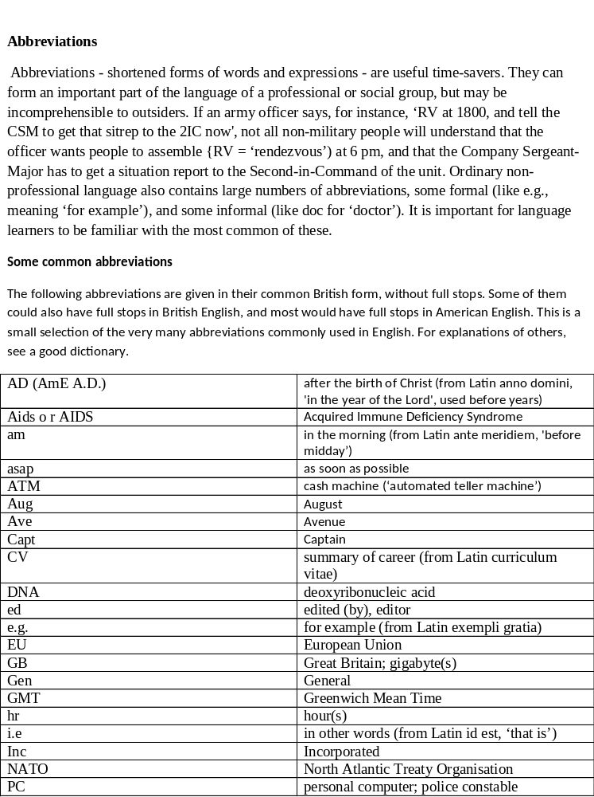’
uni | University
VAT | value added tax
vol | Volume
WWW | world wide web
yd | yard(s)
NOTE : Refer to Michael Swan’s Practical English Usage for Abbreviation and Affixes.

